Microservices Architecture using ASP.NET Core Web API

Aim:
To implement JWT (JSON Web Token) authentication in an ASP.NET Core Web API by creating a login endpoint that generates a JWT token after successful user authentication.
Software Requirements:
- Visual Studio 2022
- .NET 10 SDK
- ASP.NET Core Web API
- Swagger UI
- NuGet Packages:
  - Microsoft.AspNetCore.Authentication.JwtBearer
  - Microsoft.AspNetCore.OpenApi
  - Swashbuckle.AspNetCore
Procedure:
- Open Visual Studio and create a new ASP.NET Core Web API project named JwtMicroservice.
- Install the required NuGet package Microsoft.AspNetCore.Authentication.JwtBearer to enable JWT authentication.
- Configure the JWT settings such as Key, Issuer, Audience, and Token Expiry in the appsettings.json file.
- Configure JWT Authentication and Authorization services in the Program.cs file using the authentication middleware.
- Create a LoginModel class to accept the user's username and password.
- Create an AuthController and implement the POST /api/Auth/login endpoint to receive the login credentials.
- Validate the user credentials. If the credentials are valid, generate a JWT token by adding the required claims and signing it using the secret key.
- Return the generated JWT token as the response to the client after successful authentication.
- Build and run the application, then open Swagger UI to test the login endpoint.
- Execute the POST /api/Auth/login API with valid credentials and verify that a JWT token is generated successfully

Fig. 1: ASP.NET Core Web API Project Created
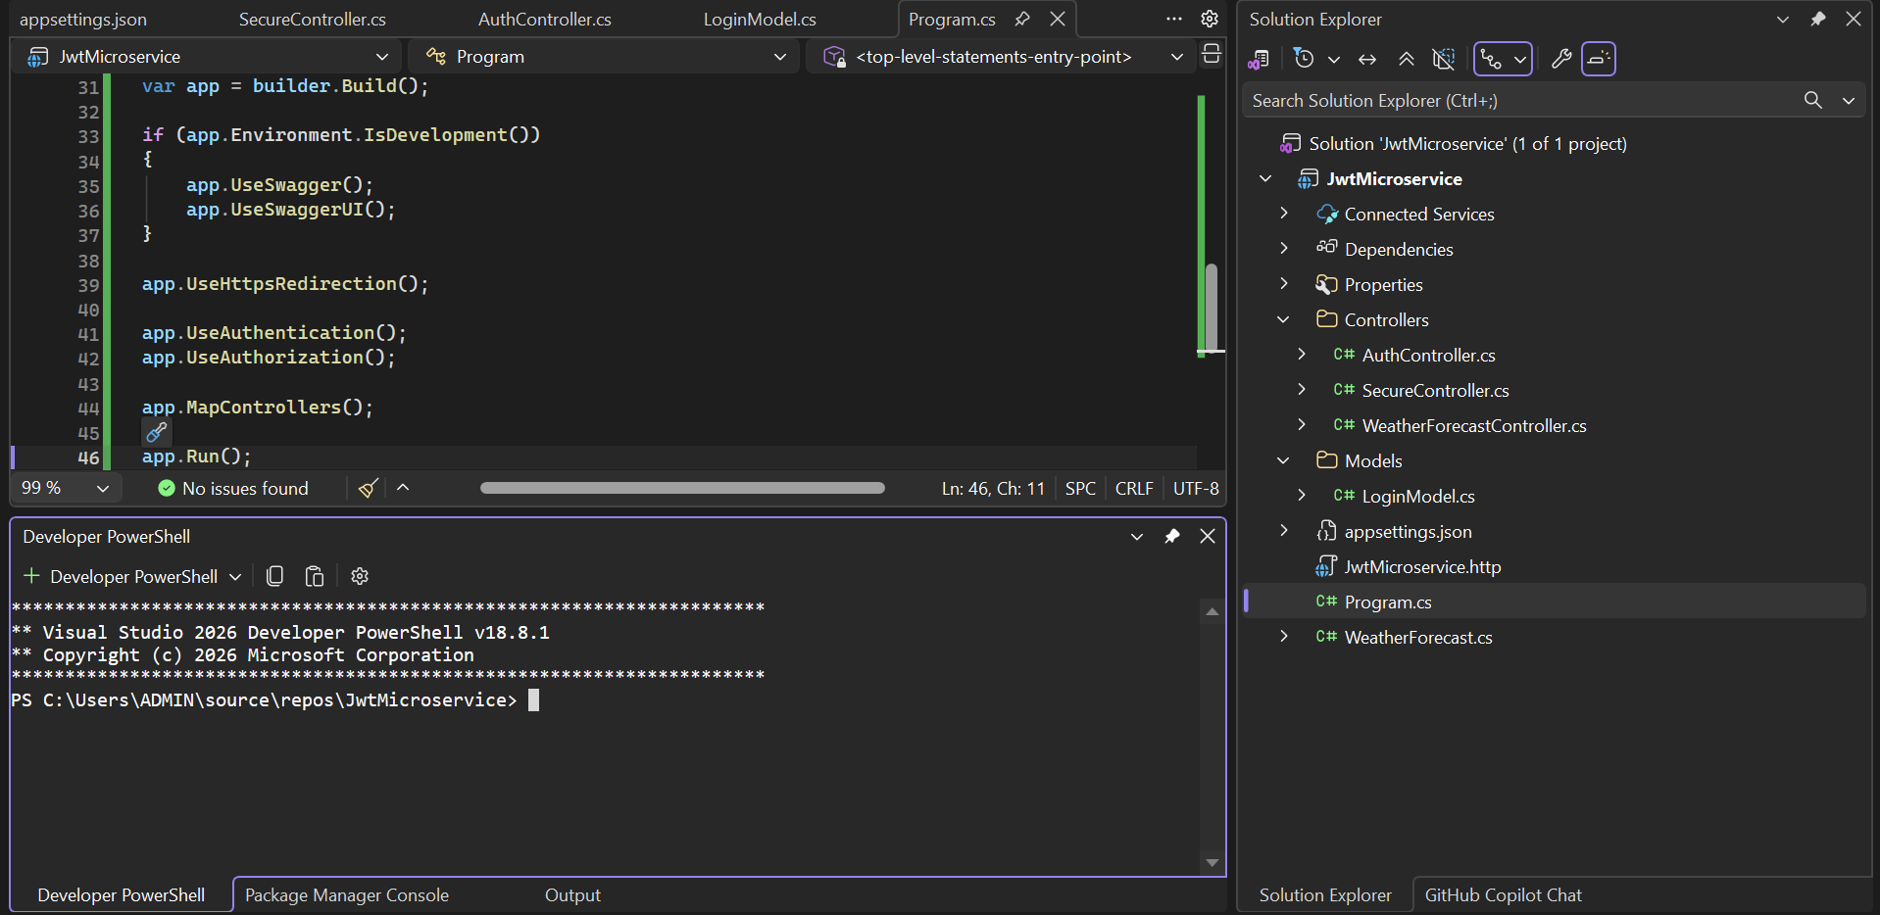

Fig. 2: JWT Configuration in appsettings.json
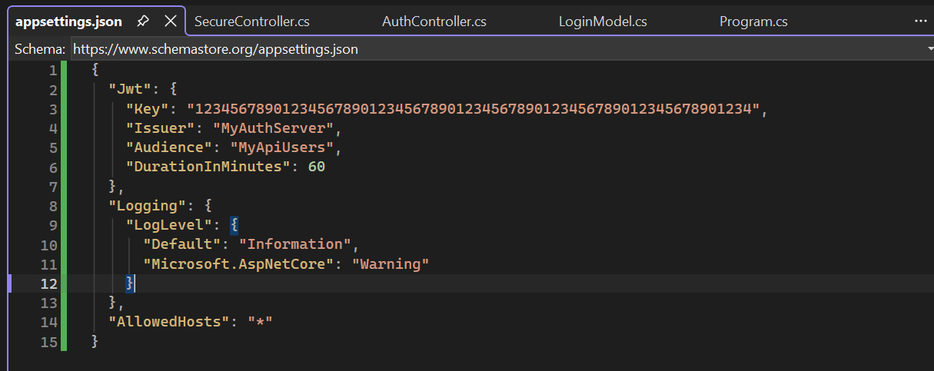

Fig. 3: Swagger Home Page
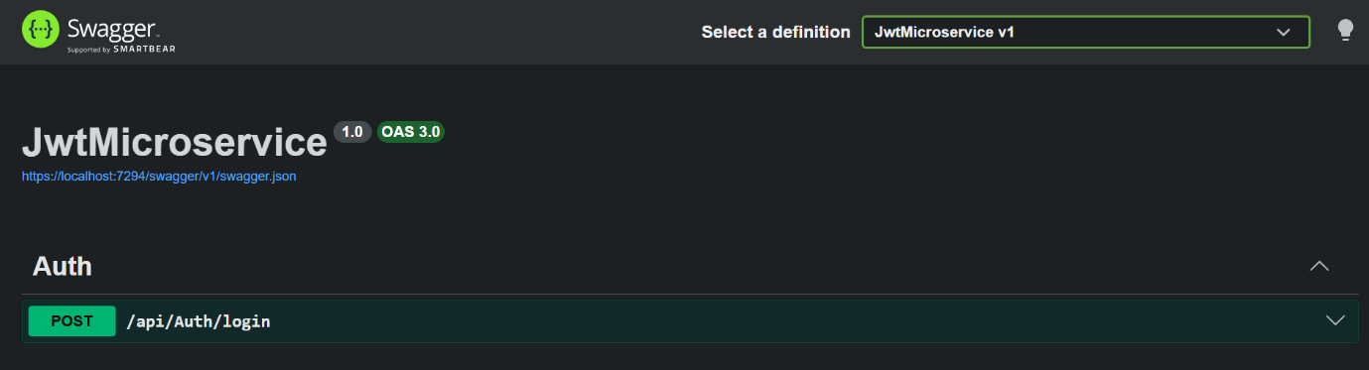

Fig. 4: Login Request and JWT Token Generated Successfully
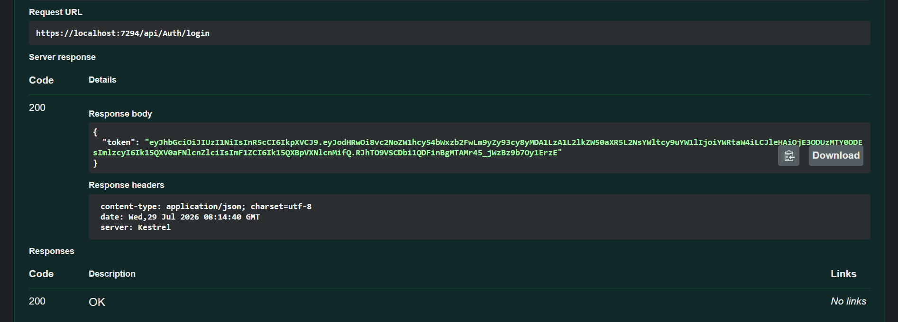

Fig. 5: Application Running Successfully
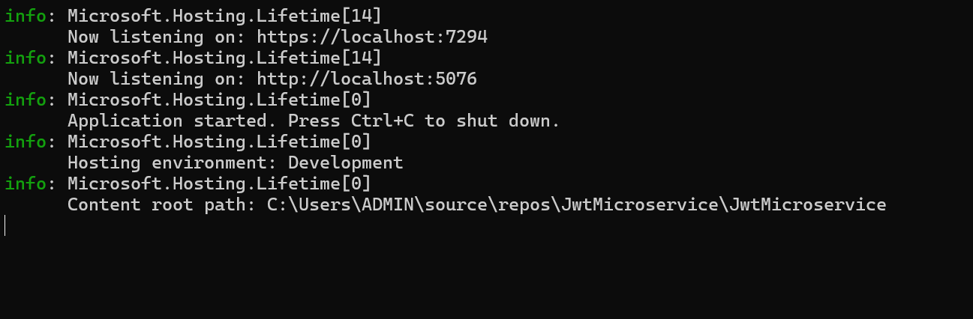

Result:
The JWT Authentication mechanism was successfully implemented in an ASP.NET Core Web API. A JWT token was generated successfully after validating the user credentials, enabling secure authentication for the application.

